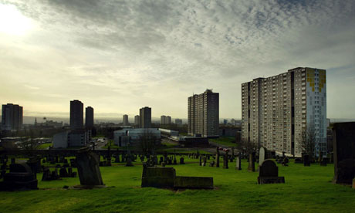
Why is Glasgow the UK’s sickest city?

Babies born in Glasgow are expected to live the shortest lives of any in Britain. One in four Glaswegian men won't reach their 65th birthday. What is behind the "Glasgow Effect" and can it be prevented?

G
lasgow is internationally renowned for its thriving arts scene and top universities. It boasts handsome Victorian architecture, smart designer shops, fashionable bars and restaurants.
At the same time, this dynamic city also has an unenviable reputation for poor health. Obesity rates are among the highest in the world. Research conducted in 2007 found that nearly one in five potential workers was on incapacity benefit and that Glasgow has a much larger number and a higher proportion of the population claiming sickness-related benefit than any other city in Britain.

What is worse, the city has an alarmingly high mortality rate. A 2011 study compared it with Liverpool and Manchester, which have roughly equal levels of unemployment, deprivation and inequality. It found that residents of Glasgow are about 30% more likely to die young, and 60% of those excess deaths are triggered by just four things - drugs, alcohol, suicide and violence.

Moreover the Glasgow Effect is relatively new. "These causes of death have emerged really since the 1990s," says Harry Burns, professor of public health at Strathclyde University. "And they emerged more dramatically in one particular sector of the population - men and women between the ages of 15 and 45. So it's a very specific pattern affecting people in their most productive years.

Walter Brown’s story:
Walter Brown, a man with a lined face and cropped grey hair, says he has had a lucky escape. As he sits drinking a cup of coffee in the cafe next to the swimming pool, he describes his agonising battle with alcohol. "The thought of giving up terrified me," he says. "Because what else do you do? Everybody I knew drank or took drugs."

He adds: "It allowed me to wear a mask - I was Jack the Lad, the tough guy full of bravado. Before I went out I would drink a quarter of a bottle of whisky and two cans of lager just to become the person people thought I was by the time I walked into the pub."

Walter suffered alcoholic seizures, temporary paralysis and cirrhosis of the liver. His doctor warned that even another litre of drink could cause permanent brain damage and even death. But that didn't put him off. "Somehow I didn't think it would happen to me," he says. "And I thought we're all going to die young anyway - we all eat rubbish and [the] government isn't going to give the likes of me a job."

The excess mortality phenomenon is a "horribly complicated" set of factors affecting different parts of the population in different ways so it's pointless searching for a "silver bullet" to solve it, he believes. Walsh says that he originally identified 17 different factors.
Some blame the cold, rainy weather and say a lack of sunlight has caused chronic vitamin D deficiency. There are theories ranging from Glaswegians' penchant for burning the candle at both ends to a culture of pessimism. Some think sectarianism between Catholics and Protestants could be responsible. Scotland's health minister Alex Neil accused Margaret Thatcher of driving the Scots to drink and drugs by destroying heavy industry back in the 1980s. Local Conservatives described the claim as preposterous and said alcoholism was too important to be treated as a political football.

What's certain is that there are no easy answers…

Abridged from BBB.com

Questions on the text.

- What is Glasgow’s bad reputation? What is the life expectancy of one in four Glaswegian men?

- What do you learn about the obesity rate in Glasgow?

- How many workers can potentially benefit from incapacity benefit?

- Most of the time, what are the different causes which may lead to premature (early) death?

- When did those factors start to appear?

- Which segment of the population is the most affected?

- What did Walter Brown suffer from?

- What did his doctor tell him?

- Give the reasons / factors which may lead to such health problems in Glasgow city. (lines 45-55)

- Translate the following expressions into French: poor health / sickness-related benefit / high mortality rate / unemployment / a lined face / alcoholic seizures / temporary paralysis / liver / permanent brain damage

